Lab No. 06

AC SUPERPOSITION



**Fall 2022**

**CSE-203L**

**Circuits & System-2 Lab**

Submitted by: **NAVEED AHMAD**

Registration No.: **22PWCSE2165**

Class Section: **B**

“On my Honor, as student of University of Engineering and Technology, I have neither given nor received unauthorized assistance on this academic work.”

Submitted to:

**Engr. Usman Malik**

11/12/2023

Department of Computer Systems Engineering

University of Engineering and Technology, Peshawar

AC SUPERPOSITION

Objective:

* This exercise examines the analysis of multi-source AC circuits using the Superposition Theorem.
* In particular, sources with different frequencies will be used to illustrate the contributions of each source to the combined result.

Theory Overview:

The Superposition Theorem can be used to analyse multi-source AC linear bilateral networks. Each sources considered in turn, with the remaining sources replaced by their internal impedance, and appropriate series-parallel analysis techniques employed. The resulting signals are then summed to produce the combined output signal. To see this process more clearly, the exercise will utilize two sources operating at different frequencies. Note that as each source has a different frequency, the inductor and capacitor appear as different reactance to the two sources.

Equipment:

1. AC Function Generators
2. Oscilloscope

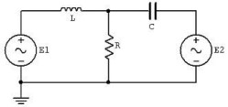

**Figure:1 show circuit diagram of experiment**

Components:

* 0 .1 µF Capacitor
* 10mH Inductor
* 1kΩ Capacitor

Procedure:

To test the Superposition Theorem, sources E1 and E2 will be examined separately and then together.

Source One Only:

* Consider the circuit of Figure 1 with C=0.1 µF, L=10mH, R=1kΩ, using only source E1=2 V p-p at 1 kHz and with source E2 replaced by a 0-V voltage source represented as a short circuit. Using standard series parallel techniques; calculate the voltages across R. Record the results in Table 1.

* Build the circuit of Figure 1 using C=0.1 µF, L=10mH, and R=1kΩ. Replace E2 with 0V voltage source represented as a short circuit. Set E1 to 2V p-p at 1 kHz, unloaded. Place probe one across E1 and probe two across R. Measure the voltages across R, and record in Table 1.

Source Two Only:

* 3. Consider the circuit of Figure 1 using only source E2=2 V p-p at 10 kHz and with source E1 replaced by 0-V voltage source represented as a short circuit. Using standard series-parallel techniques; calculate the voltages across R. Record the results in Table 2.

* 4. Replace the short circuit with source E2 and set it to 2Vp-p at 10 kHz, unloaded. Replace E1 with 0-V voltage source represented as a short circuit. Place probe one across E2 and probe two across R. Measure the voltages across R and record in Table 2.

Source One and Two:

* 5. Consider the circuit of Figure 1 using both sources, E1=2Vp-p at 1 kHz and E2=2Vp-p at 10 kHz. Add the calculated voltages across R from Tables 1 and 2. Record the results in Table 3. 6. Replace the short circuit with source E1 and set it to 2Vp-p at 1 kHz, unloaded. Both sources should now be active. Place probe one across R. Measure the voltages across R, and record in Table 3.
* 7. Repeat the experiment for 1uF capacitor, 1mH inductor and 1kΩ.

Experimental Results:

Source One Only

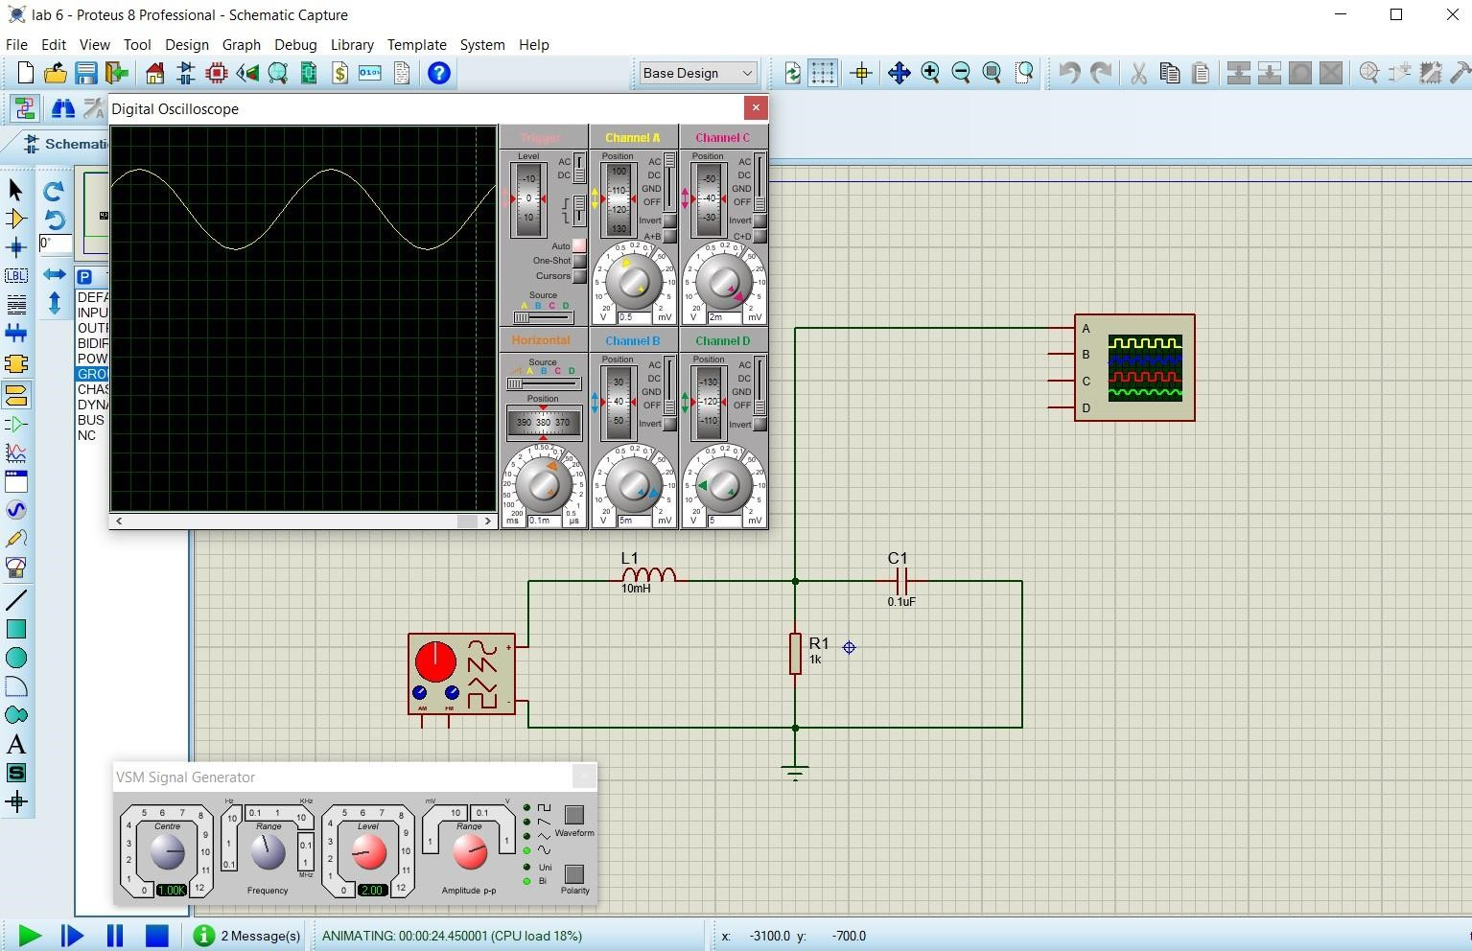

Fig 2, when source one connected

**Observation and calculation:**

|  |  |  |  |
| --- | --- | --- | --- |
|  | Theoretical | Experimental | % Deviation |
| VR | 2.078V | 2.1V | 1.1% |

Source Two Only:

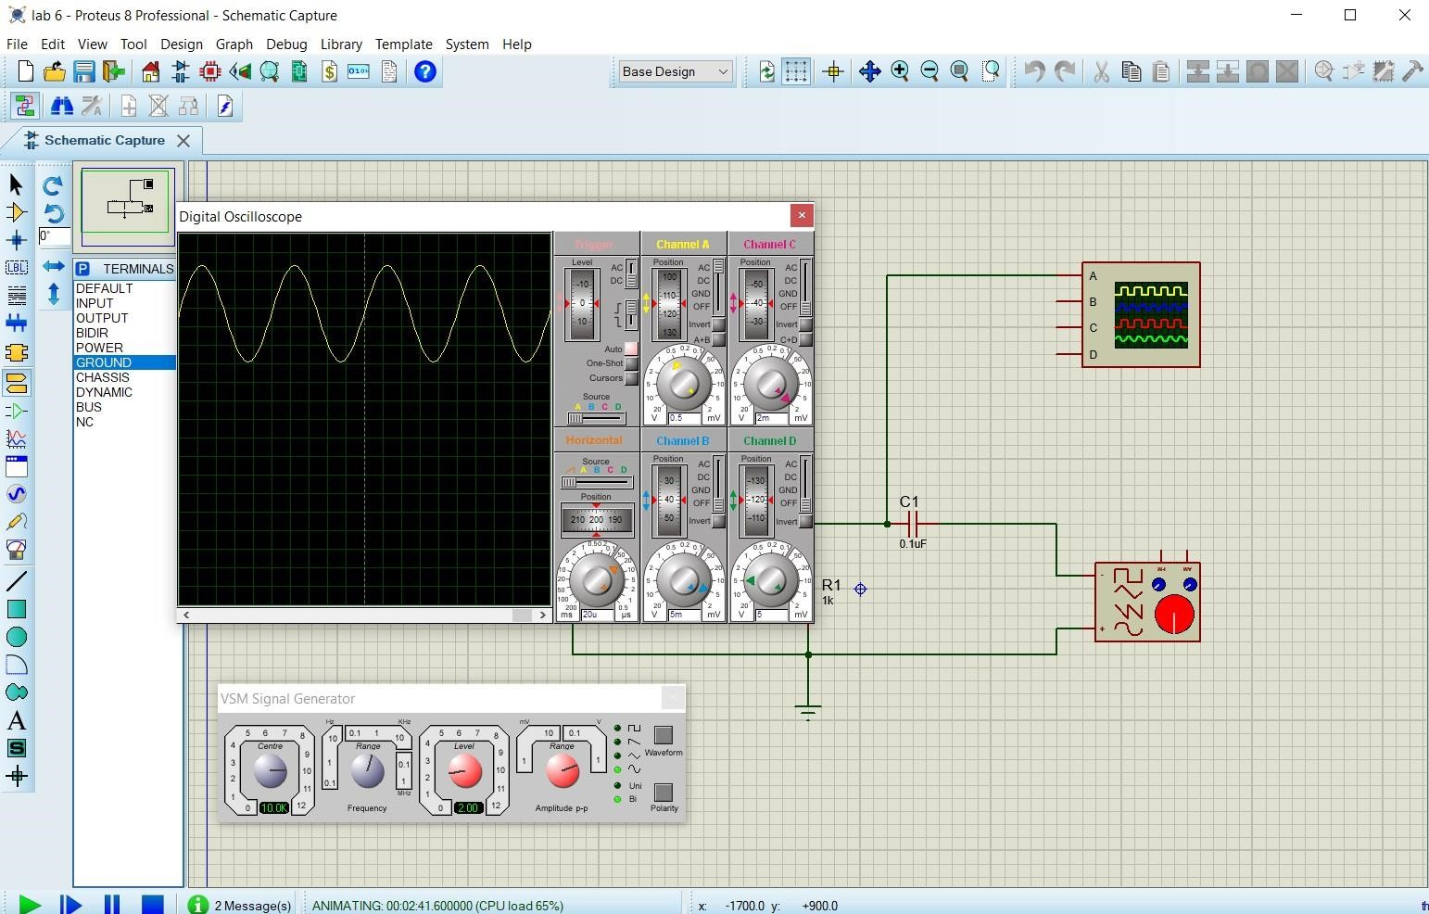

Fig 2, when source tw connected

**Observation and calculation:**

|  |  |  |  |
| --- | --- | --- | --- |
|  | Theoretical | Experimental | % Deviation |
| VR | 2.62V | 2.6V | 0.3% |

Sources One and Two:

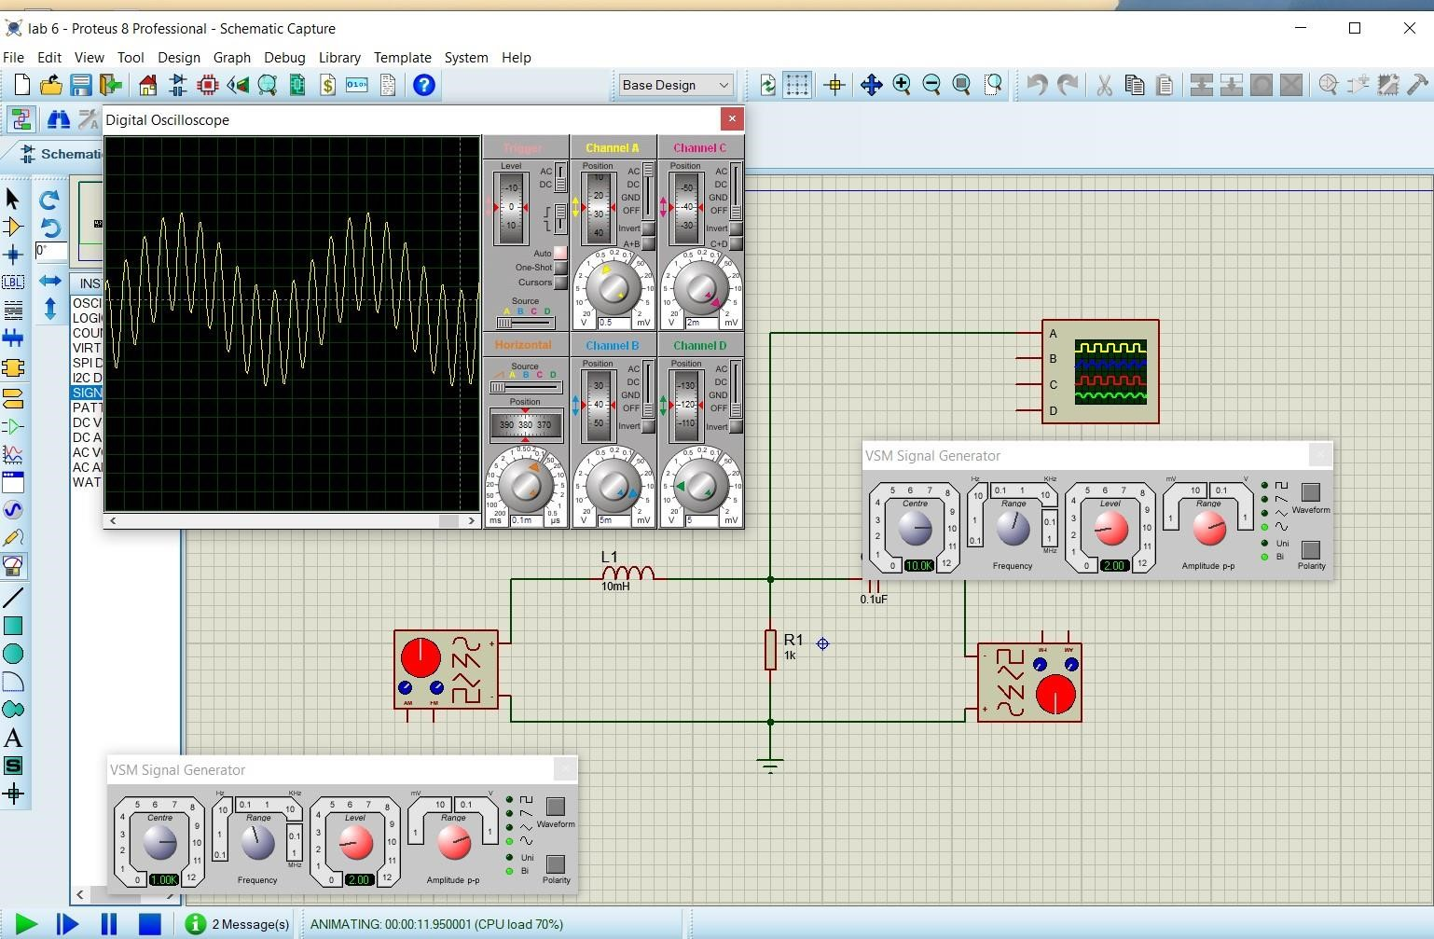

Fig No 4 when both the source (1&2)connected

Observation and Calculation:

|  |  |  |  |
| --- | --- | --- | --- |
|  | Theoretical | Experimental | % Deviation |
| VR | 4.69V | 4.7V | 0.1% |